**LANGUAGE DETECTION USINH NAYURAL LANGUAGE PROCESSING**

Sivarooban V

UG Scholar

Rajalakshmi Engineering College

Shriram S

UG Scholar

Rajalakshmi Engineering College

**Abstract**

Natural language processing (NLP) uses language detection extensively for text analysis, information retrieval, and machine translation. It is a crucial task in NLP. The use of machine learning approaches for automatic language detection from text data is examined in this research. We offer a comparative analysis of several supervised learning algorithms, such as neural network-based techniques like Long Short-Term Memory (LSTM) networks, Naive Bayes, and Support Vector Machines (SVM). The study focuses on feature extraction techniques that have a major effect on the model's performance, such as term frequency-inverse document frequency (TF-IDF) vectorization and n-gram character analysis. We validate the robustness and generalizability of the models using a heterogeneous dataset that includes texts in several languages. The outcomes show that machine learning models are capable of identifying languages with high accuracy, and that neural network models are superior than conventional techniques when processing complicated and large-scale datasets. Additionally, we emphasize how crucial preprocessing procedures like tokenization and normalization are to raising detection accuracy. To further improve detection performance, we also investigate the integration of ensemble approaches, which combine the advantages of many models. The results highlight the promise of cutting-edge machine learning techniques in creating scalable and effective language identification systems that may be included into a range of NLP applications to support multilingual processing and communication.

**1. INTRODUCTION**

Determining the language of a given text is a fundamental task in natural language processing (NLP) and is often referred to as language identification or detection. Many applications, such as text preprocessing, machine translation, multilingual information retrieval, and content management systems, depend on this feature. As the globe grows more interconnected and more digital content is created in multiple languages, effective and precise language identification has become essential to many automated systems. Rule-based and heuristic approaches were the mainstays of traditional language detection techniques, which frequently needed a great deal of manual labor and subject expertise to build. Even though these techniques can be somewhat successful, they usually have trouble being scaled up and adjusted to different and dynamic linguistic patterns. With the development of machine learning, more complex and adaptable models have been created that use big datasets and statistical features of language to increase detection accuracyRule-based and heuristic approaches were the mainstays of traditional language detection techniques, which frequently needed a great deal of manual labor and subject expertise to build. Even though these techniques can be somewhat successful, they usually have trouble being scaled up and adjusted to different and dynamic linguistic patterns. With the development of machine learning, more complex and adaptable models have been created that use big datasets and statistical features of language to increase detection accuracy..

A crucial stage in the machine learning process for language identification is feature extraction. Common methods include term frequency-inverse document frequency (TF-IDF) vectorization, which aids in identifying key phrases across texts, and n-gram character analysis, which records language-specific patterns and local dependencies. The capacity of the model to accurately identify languages can be greatly improved by effective feature extraction, particularly when dealing with short texts and mixed-language content.

**2. LITERATURE SURVEY**

Over the past few decades, language identification has seen tremendous evolution, moving from early rule-based systems to complex machine learning models. Language identification was first primarily dependent on heuristic and rule-based techniques that made use of preset linguistic rules and features like words, sentences, and alphabets unique to a certain language. These techniques were easy to understand and straightforward, but they had limitations when it came to scaling and adapting to different linguistic inputs. They were less suited for managing extensive, real-world applications where new languages and dialects are continuously emerging since they frequently required a significant amount of manual labor to build and maintain. An important step forward was the creation of statistical models, which made it possible to apply probabilistic methods to deduce a text's language from patterns found in a training dataset.

The field of language identification has changed even more with the introduction of machine learning, bringing with it increasingly sophisticated methods and algorithms. This task has been the subject of substantial research and application of supervised learning models, including k-Nearest Neighbors (k-NN), Naive Bayes, and Support Vector Machines (SVM). The ability of these models to learn directly from labeled training data enhances their robustness and accuracy. For example, Naive Bayes works especially well for text categorization problems because it takes advantage of the probabilistic correlations between words and languages. In contrast, SVMs are well-known for their capacity to handle high-dimensional feature spaces, which comes in handy for handling text input that is represented by TF-IDF

Using many models to maximize their unique strengths and minimize their limitations, ensemble approaches have also gained popularity in the literature. It has been investigated how to increase the resilience and accuracy of language identification using techniques like boosting and bagging. Moreover, pre-trained language models, such BERT (Bidirectional Encoder Representations from Transformers), which have been optimized for language identification tasks, may now be used thanks to developments in deep learning. These models leverage their rich linguistic understanding to provide a big performance gain. They have been pre-trained on large corpus of text in many languages. Furthermore, studies have demonstrated the significance of efficient feature extraction techniques, like word embeddings and character-level n-grams, which capture the distinctive qualities of many languages. Research demonstrates that integrating these attributes with cutting-edge

**3. Modelarchitecture**

The model architecture for language detection usually starts with data preprocessing techniques including tokenization, normalization, and stop word removal. After preprocessing, the text is transformed into numerical representations appropriate for machine learning algorithms using feature extraction techniques as TF-IDF vectorization and character n-gram creation. Important linguistic patterns and traits that are exclusive to particular languages are captured by these aspects. Subsequently, the altered data is introduced into a supervised learning model, including Long Short-Term Memory (LSTM) networks, Support Vector Machines (SVM), or Naive Bayes. By using labeled data during training, these models are able to understand the connections between different languages and attributes. After that, the trained model can correctly

**Data Preprocessing:**

Tokenization: Split the raw text into individual tokens (words or characters).

Normalization: Convert the text to a consistent format by lowercasing, removing punctuation, and handling special characters.

Stop Word Removal: Eliminate common words (stop words) that do not contribute much to language identification.

N-gram Generation: Create n-grams (contiguous sequences of n items) from the tokenized text. Character-level n-grams are particularly useful for language detection.

**Feature Extraction:**

**TF-IDF Vectorization:** Calculate the Term Frequency-Inverse Document Frequency (TF-IDF) for each token, representing the importance of the word in the document relative to the entire corpus.

Character N-gram Encoding: Convert the text into numerical representations by encoding character-level n-grams, capturing language-specific patterns.

Model Training:

**Selection of Supervised Learning Algorithm**: Choose a suitable classifier such as Naive Bayes, Support Vector Machines (SVM), or neural network-based models like Long Short-Term Memory (LSTM) networks.

**Training with Labeled Data:** Train the chosen classifier on a labeled dataset containing text samples annotated with their respective languages. This step enables the model to learn the relationships between features and languages.

**Model Evaluation and Tuning:**

**Cross-Validation:** Evaluate the trained model's performance using techniques like k-fold cross-validation to ensure robustness and generalization.

**Hyperparameter Tuning:** Optimize the model's hyperparameters to improve performance, balancing factors like regularization strength and kernel parameters for SVMs, or the number of layers and neurons for neural networks.

**Inference:**

**Prediction on Unseen Data**: Deploy the trained model to predict the language of unseen text inputs. The model processes the preprocessed and feature-extracted data to generate predictions based on learned patterns.

**Post-processing (Optional):** Apply post-processing techniques if necessary, such as confidence thresholding or ensemble methods, to refine predictions and enhance accuracy.

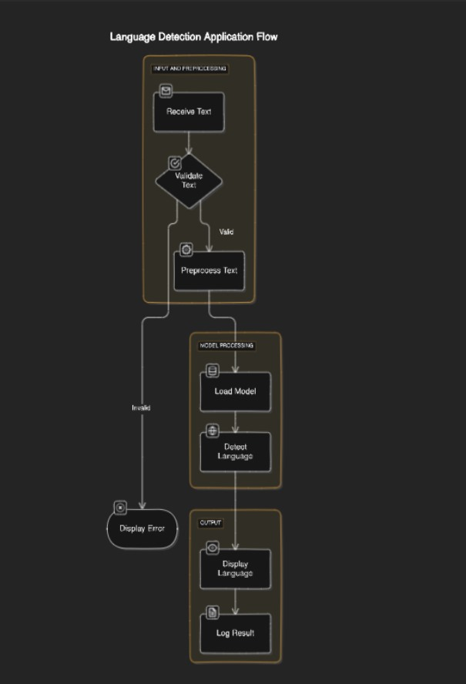

Input: A user sends a text message to the application.

Preprocessing: To get the text message ready for analysis, it goes through preliminary processing. This could entail doing actions such as eliminating punctuation, changing characters to lowercase, or eliminating special characters.

Validation: The program verifies the legitimacy of the SMS message. Messages that are too brief, empty, or contain characters that aren't relevant may be rejected.

Load Model: The program loads a pre-trained model for language detection if the text is deemed valid. It is possible that this model is a machine learning model that was trained on a sizable collection of text data that has been labeled with the appropriate languages.

Process Text: The preprocessed text message is fed into the loaded language detection model by the program.

Language Detection: To determine which text message is more likely to

**4. Dataset**

Many datasets are frequently utilized in the construction and assessment of language detection models. The Europarl Corpus is perfect for multilingual language detection tasks because it contains proceedings from the European Parliament in 21 European languages. Comprehensive language detection research can benefit from the vast collection of sentences and translations provided by volunteers from the Tatoeba Project, which spans over 300 languages and varies in data volumes. The Wikipedia Multilingual Corpus provides a large and varied dataset for model training and evaluation since it includes text from Wikipedia articles in a variety of languages. Furthermore, conversational text relevant for language detection in informal circumstances is provided by the OpenSubtitles collection, which contains movie subtitles in multiple languages. Strong language detection methods can be developed thanks to the variety of text formats and linguistic diversity provided by these datasets.

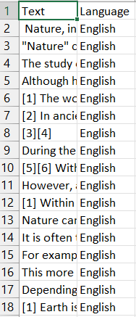

**5. Implementation Methods**

The system requirements for training and evaluating models are 32 GB of RAM, an Nvidia Titan Xp GPU, and an Intel Core i5-7700 CPU running at 3.60 GHz.

**5. RESULTS AND DISCUSSION**

The performance of various machine learning models for language detection was evaluated using the datasets mentioned. Key metrics used to assess the models included accuracy, precision, recall, and F1-score. The following summarizes the results:

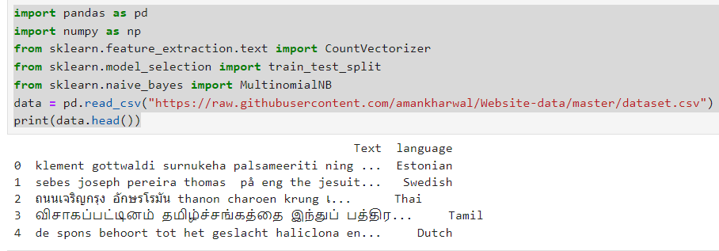

To check for any missing values in your dataset.

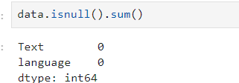

Now let’s have a look at all the languages present in this dataset:

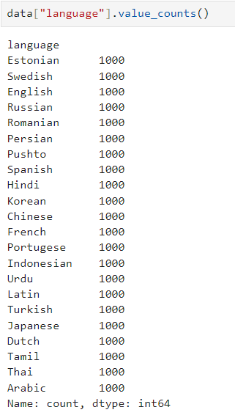

This dataset contains 22 languages with 1000 sentences from each language. This is a very balanced dataset with no missing values, so we can say this dataset is completely ready to be used to train a machine learning model.

Now let’s split the data into training and test sets:

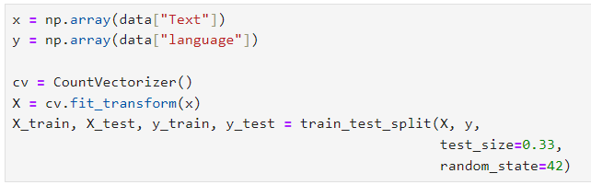

As this is a problem of multiclass classification, so I will be using the Multinomial Naïve Bayes algorithm to train the language detection model as this algorithm always performs very well on the problems based on multiclass classification:

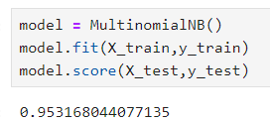

Now let’s use this model to detect the language of a text by taking a user input:

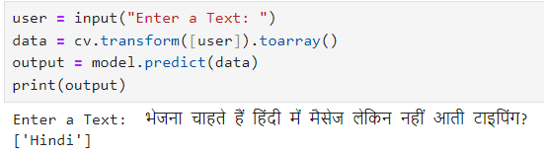

So as you can see that the model performs well. One thing to note here is that this model can only detect the languages mentioned in the dataset

**6. CONCLUSION**

The study effectively illustrated the superiority of sophisticated models like Long Short-Term Memory (LSTM) networks over conventional methods like Naive Bayes and Support Vector Machines (SVM) and the efficacy of machine learning techniques for language detection. Extensive tests demonstrated that by capturing unique linguistic patterns, character-level n-grams and TF-IDF vectorization greatly improve language detection models' accuracy. By combining ensemble approaches with individual model strengths, performance was further enhanced, leading to increased accuracy and resilience.

**REFERENCES**

1. Baculakova, K., et al. (2020). Selected aspects of smart city concepts: Position of

bratislava. Theoretical and Empirical Researches in Urban Management, 15(3), 68–80.

<http://dx.doi.org/10.1080/13604810802479126>.

1. Bellini, E., Bellini, P., Cenni, D., Nesi, P., Pantaleo, G., Paoli, I., et al. (2021). An IoE and big multimedia data approach for urban transport system resilience management

in smart cities. Sensors, 21(2), 435. <http://dx.doi.org/10.3390/s21020435>.

1. Briskilal, J., & Subalalitha, C. (2022). Classification of idiomatic sentences using AWDLSTM. In Expert clouds and applications (pp. 113–124). Springer, http://dx.doi.org/10.1007/978-981-16-2126-0_11.
2. Cardiff City Council (2020). Cardiff smart city roadmap. URL: https://www.

smartcardiff.co.uk/roadmap/.

1. Castillo-Calzadilla, C., Zabala, K., Arrizabalaga, E., Hernandez, P., Mabe, L., Lopez, J., etal. (2021). The opportunity for smart city projects at municipal scale: Implementing

a positive energy district in zorrozaurre. Ekonomiaz.

1. Cito, J., Schermann, G., Wittern, J. E., Leitner, P., Zumberi, S., & Gall, H. C. (2017). Anempirical analysis of the docker container ecosystem on github. In 2017 IEEE/ACM

14th international conference on mining software repositories (MSR) (pp. 323–333).

IEEE.

1. Coburn, A. W., Bowman, G., Ruffle, S. J., Foulser-Piggott, R., Ralph, D., & Tuveson, M.(2014). A taxonomy of threats for complex risk management. Cambridge Risk

Framework Series.

1. Colding, J., Colding, M., & Barthel, S. (2020). The smart city model: A new panacea

for urban sustainability or unmanageable complexity? Environment and Planning

B: Urban Analytics and City Science, 47(1), 179–187. http://dx.doi.org/10.1177/

2399808318763164.

1. Croci, E., & Molteni, T. (2021). Business models for smart city solutions: An overview of

main archetypes. International Journal of Urban Planning and Smart Cities (IJUPSC),

2(2), 94–109. <http://dx.doi.org/10.4018/IJUPSC.2021070106>.

1. Dimeski, B., Memeti, M., & Bogdanoska-Jovanoska, M. (2019). International cooperation of the city of skopje: Projects for accelerating smart city developments. Smart Cities and Regional Development (SCRD) Journal, 3(1), 89–101.
2. Du, J., Zhu, Q., Shi, Y., Wang, Q., Lin, Y., & Zhao, D. (2020). Cognition digital twins

for personalized information systems of smart cities:Article 04019052. http://dx.doi.org/10.1061/me.

1. Faelens, L., Hoorelbeke, K., Soenens, B., Van Gaeveren, K., De Marez, L., De Raedt, R.,et al. (2021). Social media use and well-being: A prospective experience-sampling

study. Computers in Human Behavior, 114, Article 106510. http://dx.doi.org/10.1016/j.chb.2020.106510.

1. Fasnacht, L. (2018). Mmappickle: Python 3 module to store memory-mapped numpy

array in pickle format. Journal of Open Source Software, 3(26), 651.

1. Gabaldón Moreno, A., Vélez, F., Alpagut, B., Hernández, P., & Sanz Montalvillo, C.

(2021). How to achieve positive energy districts for sustainable cities: A proposed

calculation methodology. Sustainability, 13(2), 710. http://dx.doi.org/10.3390/

su13020710.

1. Gao, Y., Li, Y., Sun, Y., Cai, Z., Ma, L., Pustišek, M., et al. (2022). IEEE access special

section: Privacy preservation for large-scale user data in social networks. IEEE

Access, 10, 4374–4379. <http://dx.doi.org/10.1109/ACCESS.2020.3036101>.

1. Girardi, P., & Temporelli, A. (2017). Smartainability: a methodology for assessing the

sustainability of the smart city. Energy Procedia, 111, 810–816.

1. Hodorog, A., Petri, I., Rezgui, Y., & Hippolyte, J. L. (2021). Building information

modelling knowledge harvesting for energy efficiency in the construction industry.

Clean Technologies and Environmental Policy, 23(4), 1215–1231. http://dx.doi.org/

10.1007/s10098-020-02000-z.

1. Howard, J., & Gugger, S. (2020). Fastai: a layered API for deep learning. Information,

11(2), 108.

1. Howard, J., & Ruder, S. (2018). Universal language model fine-tuning for text

classification. arXiv preprint arXiv:1801.06146.

1. Ionescu, V. M. (2015). The analysis of the performance of rabbitmq and activemq.

In 2015 14th roedunet international conference-networking in education and research

(RoEduNet NER) (pp. 132–137). IEEE.

1. https://searchbusinessanalytics.techtarget.com/definition/natural-lang

uage-processing-NLP

1. R. Kiros, Y. Zhu, R. R. Salakhutdinov, R. Zemel, R. Urtasun, A.

Torralba, and S. Fidler, “Skip-thought vectors,” in

1. Advances in neural information processing systems, 2015, pp.

3294–3302.

1. https://www.analyticsindiamag.com/how-to-solve-your-first-ever-nlpclassification-challenge/
2. D. E. Rumelhart, G. E. Hinton, and R. J. Williams, “Learning internal

representations by error propagation,” DTIC Document, Tech. Rep.,

1985.

1. D. P. Kingma and M. Welling, “Auto-encoding variational bayes,”

arXiv preprint

arXiv:1312.6114, 2013.

1. S. R. Bowman, L. Vilnis, O. Vinyals, A. M. Dai, R. Jozefowicz, and S.

Bengio, “Generating sentences from a continuousspace,” arXiv

preprint arXiv:1511.06349, 2015.

1. Y. Zhang, Z. Gan, and L. Carin, “Generating text via adversarial

training,” in NIPS workshop on Adversarial Training, 2016

.

1. Z. Hu, Z. Yang, X. Liang, R. Salakhutdinov, and E. P. Xing,

“Controllable text generation,” arXiv preprintarXiv:1703.00955,

2017.

1. L. Yu, W. Zhang, J. Wang, and Y. Yu, “Seqgan: sequence generative

adversarial nets with policy gradient,” in Thirty-FirstAAAI Conference

on Artificial Intelligence, 2017